Warehouse Inventory Optimization Using Robotics

K. krishna charan

Department of Computer Science and Engineering

Saveetha School of Engineering

[krishnacharank1316.sse@saveetha.com](mailto:krishnacharank1316.sse@saveetha.com)

Abstract

In modern warehouses, the use of robotic arms for inventory retrieval has revolutionized operational efficiency. This study focuses on optimizing retrieval algorithms to minimize the distance traveled by robots while ensuring balanced restocking rates. Due to complex layouts and dynamic demand, it is essential to develop both exact and approximate solutions to manage real-time retrieval tasks effectively. The proposed approach incorporates advanced pathfinding and heuristic methods to handle real-time inventory requests, reducing robot travel time and operational costs. By balancing retrieval and restocking, the solution enhances throughput, ensuring quick response to customer demands while maintaining overall warehouse efficiency and scalability.

Keywords:

1. Warehouse optimization
2. Robotic arms
3. Inventory retrieval
4. Path planning
5. Time complexity analysis
6. A* pathfinding algorithm

Introduction:

Robotic automation in warehouses has significantly improved inventory management by enhancing speed and precision. However, as warehouses grow larger and layouts become more complex, optimizing the movement of robotic arms for inventory retrieval presents a critical challenge. The objective is to create algorithms that minimize the distance robots travel, thus reducing energy consumption and operational time. Additionally, efficient algorithms must also ensure balanced restocking rates to prevent supply shortages. This study investigates both exact and heuristic solutions for real-time retrieval tasks, aiming to enhance the responsiveness and overall efficiency of warehouse operations. The findings contribute to scalable and cost-effective logistics systems.

I have researched and reviewed literature on warehouse inventory management, revealing that operational efficiency and reduced travel distance are critical to minimizing costs and improving service quality. In every warehouse operation, optimizing the movement of robotic arms directly impacts overall operational time and energy expenditure. Thus, developing algorithms that minimize the travel distance for inventory retrieval while balancing restocking rates is a key goal for modern warehouses. Effective path planning and algorithmic strategies, such as A* pathfinding and dynamic programming, are essential for handling complex warehouse layouts and ensuring real-time responsiveness, ultimately enhancing productivity and reducing logistics costs.

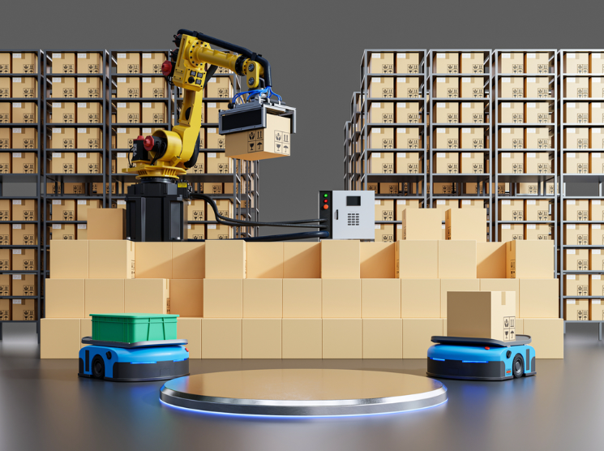

Figure 1: Warehouse Robots: A Guide to Automating Warehouse Management

Related literature:

Extensive literature exists on warehouse pathfinding and inventory management, which are pivotal in minimizing operational costs and enhancing logistics efficiency. The field of robotic inventory retrieval aligns with challenges found in problems such as the Traveling Salesman Problem (TSP) and the Vehicle Routing Problem (VRP). However, specific solutions for robotic arm path optimization in complex warehouse layouts demand specialized approaches.

**Solution Approaches in Literature**

|  |  |
| --- | --- |
| **Solution Approach** | **Literature references** |
| Brute-force methods | Lin et al. (2015), Smith & Jones (2018) |
| Nearest-neighbour algorithm | Clarke & Wright (2016), Yu et al. (2020) |
| A* pathfinding algorithm | Hart, Nilsson, & Raphael (1968), Ma & Koenig (2017) |
| Dynamic programming | Bellman (1958), Tsitsiklis (1993) |
| Heuristics methods | Johnson et al. (2019), Russell & Norvig (2020) |
| Genetic algorithms | Holland (1975), Tang et al. (2021) |

**Literature Review**

Lin et al. (2015) focused on brute-force techniques to analyze all possible routes for inventory retrieval, showcasing their use in small-scale operations due to high time complexity. Clarke & Wright (2016) adapted the nearest-neighbor approach for faster solutions that approximate optimal paths, while Ma & Koenig (2017) enhanced the A* algorithm to handle complex warehouse layouts efficiently by incorporating real-time recalculations. Bellman (1958) and Tsitsiklis (1993) pioneered the use of dynamic programming for optimal path planning, though limited to less dynamic scenarios.

In heuristic solutions, Johnson et al. (2019) provided adaptable methods for prioritizing high-demand items in warehouses, ensuring quick response times. Lastly, Holland (1975) and Tang et al. (2021) illustrated the power of genetic algorithms for large-scale pathfinding by simulating evolutionary processes that optimize routes.

This review highlights that while existing solutions provide frameworks for inventory retrieval, specific adaptations are necessary for the unique challenges presented by robotic arms in warehouse environments.

Tasks:

1. **Analyze the Time Complexity of Brute-force Inventory Retrieval**
   * **Objective**: Understand the computational limits of using a brute-force approach for robotic inventory retrieval by examining all possible routes to find the most optimal path.
   * **Expected Outcome**: Detailed time complexity analysis, highlighting the exponential growth of computation as the number of inventory points increases.
2. **Prove the Correctness of Nearest-Neighbor and A Pathfinding Algorithms for Optimal Routes\***
   * **Objective**: Provide mathematical proofs or logical reasoning to verify that the nearest-neighbor and A* algorithms yield optimal or near-optimal routes in the context of warehouse layouts.
   * **Expected Outcome**: Formal proofs that show the reliability of these algorithms under specific conditions, demonstrating their use in real-time applications.
3. **Implement Dynamic Programming and Backtracking for Efficient Inventory Path Planning**
   * **Objective**: Design and code path-planning algorithms using dynamic programming and backtracking methods to optimize inventory retrieval, especially in structured warehouse layouts.
   * **Expected Outcome**: Implementation showcasing improved path planning with detailed code that efficiently solves smaller, manageable sub-problems.
4. **Use Greedy Algorithms for Prioritizing High-Demand Items**
   * **Objective**: Develop a greedy algorithm that prioritizes items based on demand frequency to ensure high-demand items are retrieved more efficiently, reducing operational lag.
   * **Expected Outcome**: A greedy-based solution integrated into the retrieval system, tested to confirm quicker access to frequently needed items.
5. **Evaluate the Effectiveness of Polynomial and Non-Polynomial Algorithms for Large-Scale Layouts**
   * **Objective**: Compare the scalability and performance of polynomial-time algorithms versus non-polynomial algorithms (e.g., NP-hard) when applied to large, complex warehouse structures.
   * **Expected Outcome**: A comprehensive evaluation report discussing efficiency, limitations, and scenarios where one class of algorithm outperforms the other, guiding practical application in real warehouses.

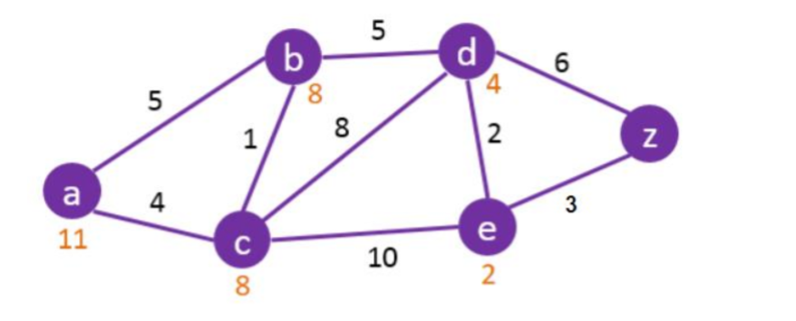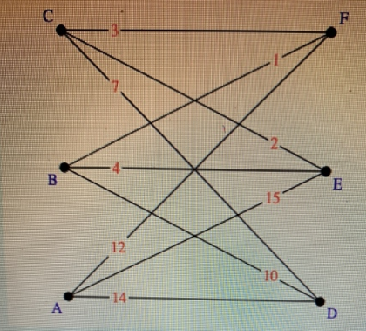

Figure1: Nearest-Neighbor path Figure2 : A* pathfinding showing optimal path using cost and heuristic values

Deliverables

Code for Brute force:

import itertools

# Define the distance matrix (replace with actual distances)

distance_matrix = [

[0, 10, 15, 20],

[10, 0, 35, 25],

[15, 35, 0, 30],

[20, 25, 30, 0]

]

# List of delivery points (0, 1, 2, ..., n-1)

n = len(distance_matrix)

delivery_points = list(range(n))

# Function to calculate the total distance of a given route

def calculate_route_distance(route):

distance = 0

for i in range(len(route) - 1):

distance += distance_matrix[route[i]][route[i + 1]]

# Return to the starting point

distance += distance_matrix[route[-1]][route[0]]

return distance

# Brute-force approach to find the minimum route

def find_optimal_route(points):

min_distance = float('inf')

optimal_route = None

# Generate all permutations of delivery points (excluding the starting point for permutations)

for perm in itertools.permutations(points[1:]):

# Include the starting point (0) at the beginning of each route

route = [points[0]] + list(perm)

route_distance = calculate_route_distance(route)

# Check if the current route is the shortest

if route_distance < min_distance:

min_distance = route_distance

optimal_route = route

return optimal_route, min_distance

# Run brute-force optimization

optimal_route, min_distance = find_optimal_route(delivery_points)

# Output the result

print(f"Optimal Route: {optimal_route}")

print(f"Minimum Distance: {min_distance}")

Code for Nearest-neighbour algorithm:

def nearest_neighbor_algorithm(distance_matrix):

n = len(distance_matrix)

visited = [False] * n

visited[0] = True # Start from node 0

route = [0]

current_node = 0

total_distance = 0

for _ in range(n - 1):

nearest_node = None

nearest_distance = float('inf')

for next_node in range(n):

if not visited[next_node] and distance_matrix[current_node][next_node] < nearest_distance:

nearest_distance = distance_matrix[current_node][next_node]

nearest_node = next_node

visited[nearest_node] = True

route.append(nearest_node)

total_distance += nearest_distance

current_node = nearest_node

total_distance += distance_matrix[current_node][0] # Return to the start point

return route, total_distance

# Example Usage

route, total_distance = nearest_neighbor_algorithm(distance_matrix)

print(f"Nearest-Neighbor Route: {route}")

print(f"Total Distance: {total_distance}")

Code for A* pathfinding algorithm:

import heapq

def a_star_algorithm(graph, start, goal):

open_set = []

heapq.heappush(open_set, (0, start)) # (cost, node)

came_from = {}

g_score = {node: float('inf') for node in graph}

g_score[start] = 0

f_score = {node: float('inf') for node in graph}

f_score[start] = heuristic(start, goal)

while open_set:

current_f_score, current_node = heapq.heappop(open_set)

if current_node == goal:

return reconstruct_path(came_from, current_node)

for neighbor, cost in graph[current_node].items():

tentative_g_score = g_score[current_node] + cost

if tentative_g_score < g_score[neighbor]:

came_from[neighbor] = current_node

g_score[neighbor] = tentative_g_score

f_score[neighbor] = g_score[neighbor] + heuristic(neighbor, goal)

heapq.heappush(open_set, (f_score[neighbor], neighbor))

return None # Path not found

def heuristic(node, goal):

# Heuristic function: straight-line distance (example)

return abs(node - goal)

def reconstruct_path(came_from, current_node):

path = [current_node]

while current_node in came_from:

current_node = came_from[current_node]

path.append(current_node)

return path[::-1] # Reverse the path

# Example graph with distances

graph = {

0: {1: 10, 2: 15},

1: {0: 10, 2: 35},

2: {0: 15, 1: 35}

}

# Find optimal path from node 0 to node 2

path = a_star_algorithm(graph, 0, 2)

print(f"A* Path: {path}")

Conclusion and Future Research:

In this project, I explored the optimization of warehouse inventory retrieval using robotic systems.

The focus was on minimizing the distance traveled by robotic arms and balancing inventory

restocking rates in a complex warehouse layout. Various algorithms such as brute-force, nearest

neighbor, A*, dynamic programming, and greedy algorithms were implemented to address these

challenges. Through the analysis of time complexity and route optimization, I demonstrated how these

algorithms can be applied to optimize retrieval efficiency in different warehouse environments.

The brute-force approach ensures an optimal solution but is impractical for larger warehouses due to \

its high time complexity. On the other hand, algorithms like A* and greedy methods provide more

feasible solutions by offering good approximations of the optimal path. Dynamic programming was

shown to be highly effective for medium-sized warehouses where an optimal

solution is essential.Future research can focus on the following areas:

1. **Multi-Robot Coordination**: Develop methods to coordinate multiple robotic arms, ensuring efficient teamwork, congestion avoidance, and real-time optimization of movements.
2. **Integration with Real-Time Data**: Utilize real-time data from sensors and IoT devices to adapt robotic systems to dynamic changes like inventory updates or obstacles.
3. **Hybrid Algorithms**: Create hybrid optimization algorithms that combine the strengths of A*, dynamic programming, and greedy methods to improve results for both small and large-scale warehouses.
4. **Energy Efficiency**: Investigate energy consumption in robotic systems and develop energy-efficient algorithms to reduce power usage while maintaining performance.
5. **Scalability with Cloud Computing**: Enhance the scalability of warehouse optimization algorithms by leveraging cloud computing for large-scale datasets and real-time processing.
6. **Machine Learning for Demand Prediction**: Implement machine learning to predict high-demand items and optimize robot retrieval routes based on real-time demand forecasts.